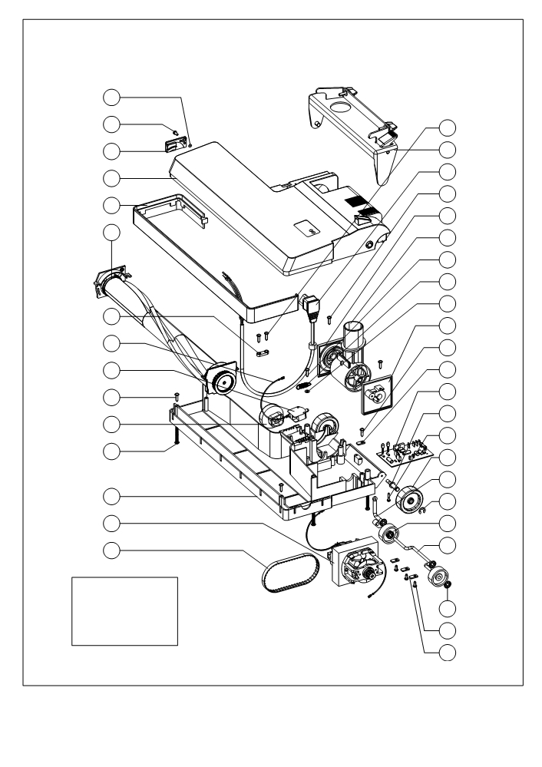

BETCO Drawing Reference A

Sub-assembly bottom compartment DM1800

1

2

3

4

5

6

37

7

8

9

10

11

12

13

14

38

15
16
17

18
19

20

21
22

23
24

25

26

27

28

29

30

31

32

33

34

35

36

BETCO Drawing Reference A

Sub-assembly bottom compartment DM1800
 | ITEM | SKU | DESCRIPTION | QTY
 | 1 | E82103 | Washer, Fiber 6, 5X2X0.5 | 1
 | 2 | E82097 | DM1400/1800 screw | 1
 | 3 | E82175 | DM1400/1800 brush strip cover | 1
 | 4 | E82234 | DM1800 brush cover | 1
 | 5 | E82176 | Brush Bumper Black, 18" | 1
 | 6 | E82248 | DM1800 roller brush complete | 1
 | 7 | E82198 | DM1400/1800 wire | 1
 | 8 | E82199 | DM1400/1800 switch | 1
 | 9 | E82095 | Screw, 4 X 16 | 4
 | 10 | E82245 | Front Caster Adjustment Knob | 1
 | 11 | E82096 | DM1400/1800 screw | 5
 | 12 | E82235 | DM1800 brush housing bottom | 1
 | 13 | E85880 | Brush motor 110v | 1
 | 14 | E86077 | Drive Belt 130XL 5/16" New Style | 1
 | 15 | E82242 | DM1400/1800 bracket | 1
 | 16 | E82227 | DM1400/1800 pigtail cord | 1
 | 17 | E82095 | DM1400/1800 screw | 1
 | 18 | E82243 | Swivel Guide Plate W/Felt | 1
 | 19 | E82178 | DM1400/1800 swivel neck | 1
 | 20 | E82097 | DM1400/1800 screw | 2
 | 21 | E82187 | DM1400/1800 spring | 1
 | 22 | E82104 | Washer M4 | 2
 | 23 | E82244 | Swivel Guide Plate W/Felt NW | 1
 | 24 | E82095 | DM1400/1800 screw | 1
 | 25 | E82179 | DM1400/1800 front caster shaft plate | 4
 | 26 | E82201 | DM1400/1800 circuit board | 1
 | 27 | E82185 | DM1400/1800 rear caster shaft | 2
 | 28 | E82095 | DM1400/1800 screw | 2
 | 29 | E82183 | DM1400/1800 rear wheel | 2
 | 30 | E88086 | Shaft DM1800 | 1
 | 31 | E82184 | DM1400/1800 clip | 2
 | 32 | E82186 | DM1400/1800 front wheel | 2
 | 33 | E82197 | Front Caster Shaft | 1
 | 34 | E82196 | DM1400/1800 starlock washer | 4
 | 35 | E82097 | DM1400/1800 screw | 3
 | 36 | E82179 | DM1400/1800 front caster shaft plate | 3
 | 37 | E82101 | Cable Restrain | 1
 | 38 | E82222 | Screw 4.2 X 1.3 | 2

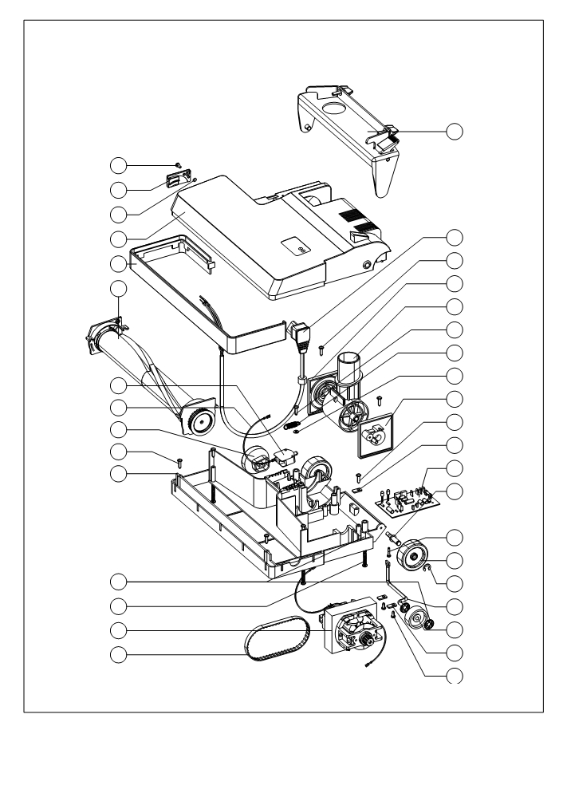

BETCO Drawing Reference B

Sub-assembly bottom compartment DM1400

1
2
3
4
5
6

7
8

9
10
11

35

12
13
14

15

16

17

18
19

20

21
22
23
24
25

26
27

28
29
30

31
32
33
34

BETCO Drawing Reference A

Sub-assembly bottom compartment DM1400
 | ITEM | SKU | DESCRIPTION | QTY
 | 1 | E82097 | DM1400/1800 screw | 1
 | 2 | E82175 | DM1400/1800 brush strip cover | 1
 | 3 | E82103 | Washer, Fiber 6, 5X2X0.5 | 1
 | 4 | E82233 | DM1400 brush cover | 1
 | 5 | E82177 | Brush Bumper Black, 14" | 1
 | 6 | E82247 | DM1400 roller brush complete | 1
 | 7 | E82199 | DM1400/1800 switch | 1
 | 8 | E82198 | DM1400/1800 wire | 1
 | 9 | E82245 | Front Caster Adjustment Knob | 1
 | 10 | E82095 | Screw, 4 X 16 | 4
 | 11 | E82236 | DM1400 brush housing bottom | 1
 | 12 | E82096 | DM1400/1800 screw | 5
 | 13 | E85880 | Brush motor 110v | 1
 | 14 | E86077 | Drive Belt 130XL 5/16" New Style | 1
 | 15 | E82242 | DM1400/1800 bracket | 1
 | 16 | E82227 | DM1400/1800 pigtail cord | 1
 | 17 | E82095 | DM1400/1800 screw | 1
 | 18 | E82243 | Swivel Guide Plate W/Felt | 1
 | 19 | E82178 | DM1400/1800 swivel neck | 1
 | 20 | E82097 | DM1400/1800 screw | 2
 | 21 | E82187 | DM1400/1800 spring | 1
 | 22 | E82104 | Washer M4 | 2
 | 23 | E82244 | Swivel Guide Plate W/Felt NW | 1
 | 24 | E82095 | DM1400/1800 screw | 2
 | 25 | E82179 | DM1400/1800 shaft plate | 4
 | 26 | E82201 | DM1400/1800 circuit board | 1
 | 27 | E82185 | DM1400/1800 rear caster shaft | 2
 | 28 | E82095 | DM1400/1800 screw | 2
 | 29 | E82183 | DM1400/1800 rear wheel | 2
 | 30 | E82184 | DM1400/1800 clip | 1
 | 31 | E82195 | DM 1400 Front Castor Shaft | 2
 | 32 | E82186 | DM1400/1800 front wheel | 2
 | 33 | E82179 | DM1400/1800 front caster shaft plate | 1
 | 34 | E82097 | DM1400/1800 screw | 4
 | 35 | E82196 | DM1400/1800 starlock washer | 3
 | 36 | E82179 | DM1400/1800 front caster shaft plate | 3

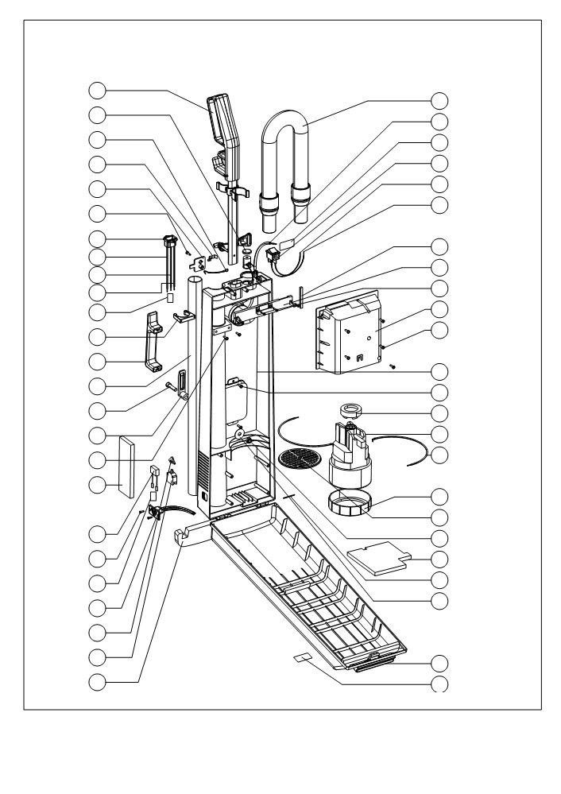

BETCO Drawing Reference C115
Sub-assembly top
Compartment DM1400 1800

1

2

3

4

5

6

8

9a

9b

115Volt

26
27
28
29
30
31

33
34
35
36
37

9c

10

11

12

13

14

15

16

17

19

20

21

22

23

24

25

35
44
45
46
47
48
49
38
39
40

50
51
41
42
36
37

38
39
40
41
42

44
45
47
48
49

50
51

BETCO Drawing Reference C115 Sub-assembly top Compartment DM1400 1800

 |  | ITEM | SKU | Description | QTY
 |  | 1 | E82237 | Handle assembly complete, aluminum | 1
 |  | 2 | E82129 | Top indicator paper bag full | 1
 |  | 3 | E82135 | Antistatic wire 50mm RNER CSA | 1
 |  | 4 | E82134 | Antistatic discharge | 1
 |  | 5 | E82131 | Antistatic cover | 1
 |  | 6 | E82095 | Screw 4x16 flat head | 1
 |  | 8 | E82226 | Inlet 3 Pole click C6/C9E | 1
 |  | 9a | E82220 | Wire white 1 mm 2 220mm F/F CSA | 1
 |  | 9b | E82219 | Wire black 1 mm 2 220mm F/F CSA | 1
 |  | 9c | E82148 | Wire GR/YEL 100mm F/F CSA | 1
 |  | 10 | E82217 | Connection Bracket 1P | 1
 |  | 11 | E82132 | Wand locker, yellow | 1
 |  | 12 | E82133 | Rear body handle | 1
 |  | 13 | E82116 | Wand 32mm aluminum telescopic | 1
 |  | 14 | E82223 | Screw Hexagon M8x3O | 1
 |  | 15 | E82216 | Cable hook external black NE | 1
 |  | 16 | E82095 | Screw 4x16 flat head | 2
 |  | 17 | E82138 | Foam filter vent | 1
 |  | 19 | E82158 | Supr. FRI Hoov with term | 1
 |  | 20 | E82100 | Screw 3, 5x13 | 2
 |  | 21 | E82218 | connection Bracket 3P | 1
 |  | 22 | E82229 | 3 Pole model CSA PL/PL/PL | 1
 |  | 23 | E82146 | Switch actuator yellow | 1
 |  | 24 | E82147 | Switch normally open | 1
 |  | 25 | E82160 | Bumper cell rubber EPDM black ZK | 1
 |  | 26 | E82239 | Hose complete 32mm, black 0.5m | 1
 |  | 27 | E82230 | Main wire 120/230 volt CSA | 1
 |  | 28 | 601895 | Label | 1
 |  | 29 | E82128 | Switch 4P with green light | 1
 |  | 30 | E82219 | Wire black 1 mm 2 220mm F/F CSA | 1
 |  | 31 | E82220 | Wire white 1 mm 2 220mm F/F CSA | 1
 |  | 33 | E82102 | Gasket 6x5mm neoprene sealed ZK | 1
 |  | 34 | E82130 | Electric Cover | 1
 |  | 35 | E82093 | Screw 3, 5x16 | 4
 |  | 36 | E82151 | Motor Housing | 1
 |  | 37 | E82095 | Screw 4x16 flat head | 5
 |  | 38 | E82231 | Rear body assembly, gray | 1
 |  | 39 | E82095 | Screw 4x16 flat head | 2
 |  | 40 | E82159 | Mounting block motor | 1
 |  | 41 | E82241 | Motor vacuum 115v | 1
 |  | 42 | E82150 | Wire BL 1 mm2 200mm PL/PL CSA | 2
 |  | 44 | E82157 | Top rubber motor | 1
 |  | 45 | E82142 | Motor grill | 1
 |  | 46 | E82224 | Nut nylon M8 | 1
 |  | 47 | E82137 | Foam motor vacuum | 1
 |  | 48 | E82154 | Door hinge shaft | 2
 |  | 49 | E82225 | Washer plan M8x30 | 1
 |  | 50 | E82232 | Front door assembly, gray | 1
 |  | 51 | 06.0189.X | Label | 1

BETCO Drawing Reference E

Front door assembly DM1400/1800
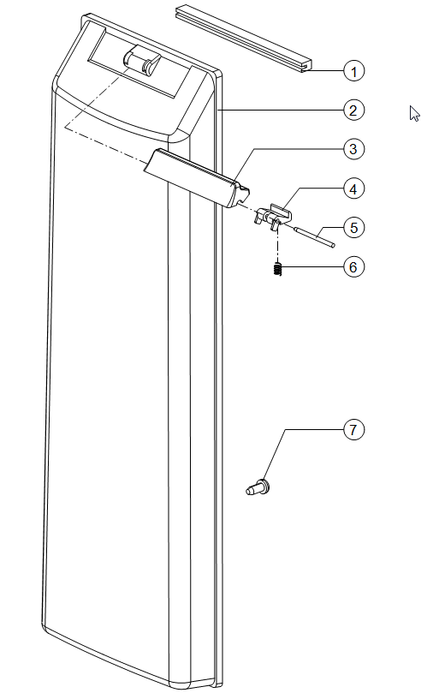

2

3

4

5

6

7

 | ITEM |  | SKU |  | DESCRIPTION |  | QTY
 | 1 |  | 06.0061.1 |  | Door Stop |  | 1
 | 2 |  | E82232 |  | DM1400/1800 front door assy |  | 1
 | 3 |  | E88098 |  | Door Opener, Black DM1400/1800 |  | 1
 | 4 |  | E88101 |  | Door Locker DM1400/1800 |  | 1
 | 5 |  | E88099 |  | Shaft Locker Cover DM1400/1800 |  | 1
 | 6 |  | E88100 |  | Spring, Door Opener DM1400/1800 |  | 1
 | 7 |  | E82099 |  | DM1400/1800 screw |  | 1

.

BETCO Drawing Reference E

Front door assembly DM1400/1800

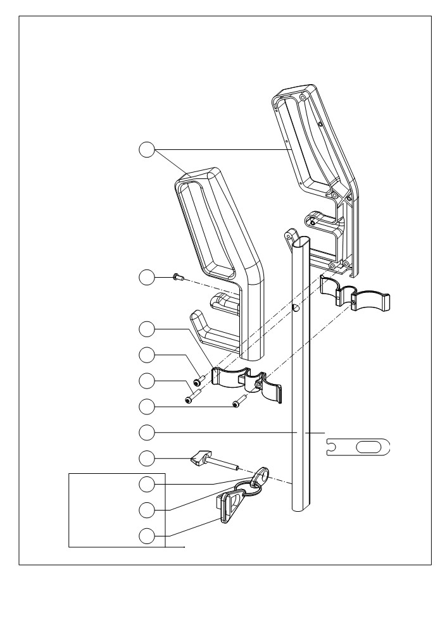

BETCO Drawing Reference F

S.01.0011.0

Handle assembly DM1400/1800

1

2

3

4

5

6
12
7

8

9

10

11

BETCO Drawing Reference F Handle assembly DM1400/1800

 | ITEM | SKU | DESCRIPTION | QTY
 | 1 | E82112 | Handle left and right | 1
 | 2 | E82097 | Screw 4x10 | 1
 | 3 | E82114 | Holder tool | 2
 | 4 | E82095 | DM1400/1800 screw | 3
 | 5 | E82094 | DM1400/1800 screw 3.5 x 25 | 1
 | 6 | E82098 | Screw 4x20 | 2
 | 7 | E82115 | Tube oval aluminum | 1
 | 8 | E82155 | Thumb screw 5 x 40, handle | 1
 | 9 | E82124 | Cable restrain 1/2 part CAN SI | 1
 | 10 | E82125 | Metal ring diam. 30mm 1/2 part | 1
 | 11 | E82126 | Cable restrain 1/2 part cable | 1
 | 12 | E82113 | Holder cable | 1

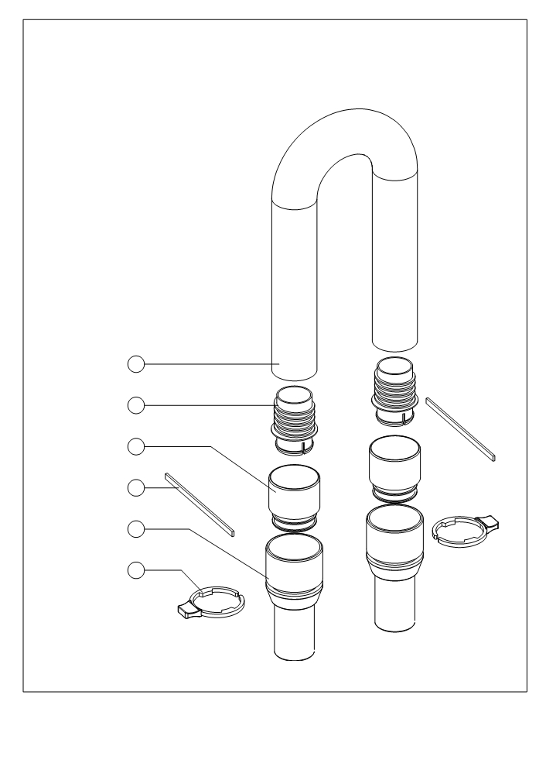

Drawing Reference G

Hose assembly with cuffs DM1400/1800

1

2
3

4
5

5

6

 | ITEM | SKU | DESCRIPTION | QTY
 | 1 | 82117 | Hose stretch 50mm 32mm, black | 1
 | 2 | 82121 | Hose end | 2
 | 3 | 82119 | Hose coupling w/o seal, black | 2
 | 4 | 82120 | Seal hose coupling 115x5x2 | 2
 | 5 | 82115 | Hose cuff 32mm, black | 2
 | 6 | 82118 | Hose clip with lip, black | 2

BETCO Drawing Reference I

Paper bag mount assembly DM1400/1800

Parts on this Page only available as an assembly,
Part number, E82240 Paper Bag Mount

.

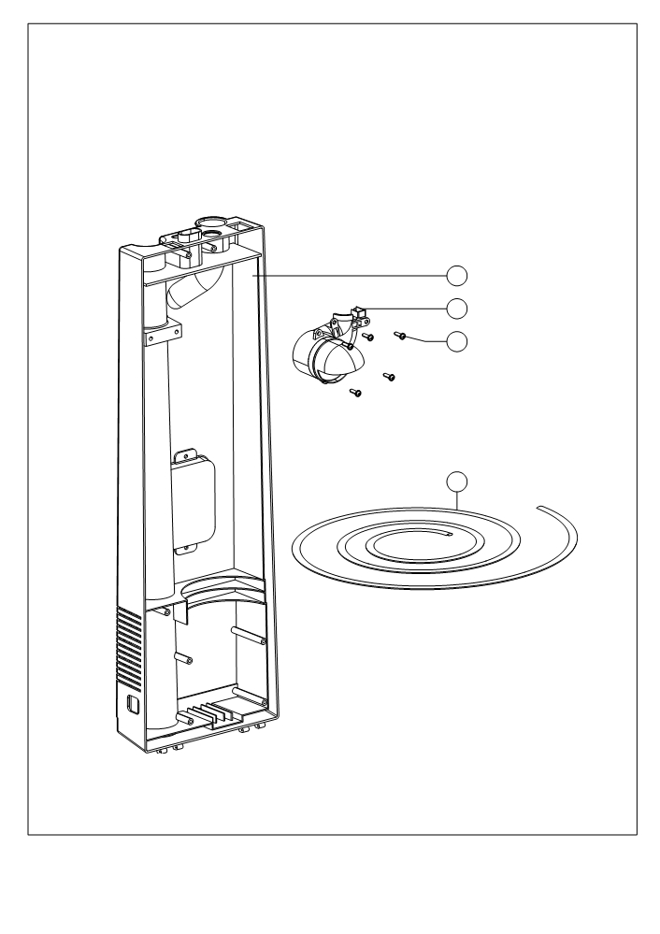

Drawing Reference J

P.04.0052.X

1

2
3

4

ITEM | SKU | DESCRIPTION | QTY
1 | E82231 | Rear body assembly, gray | 1
2 | E82240 | Paper bag mount | 1
3 | E82095 | Screw 4x16 flat head | 5
4 | E82145 | Seal front door | 1

.
.

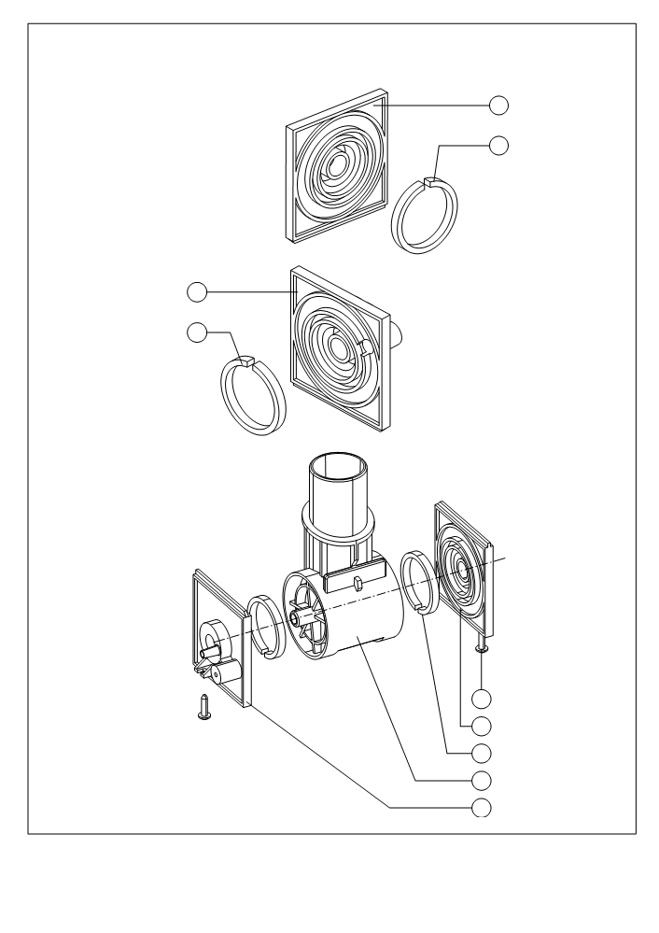

Drawing Reference L - 32 mm
FAST Specification

1 See E82243

2 See E82243

E82243

Swivel guiding plate with felt UP 350/460

See E82244 1

See E82244 2

E82244

Swivel guiding plate with felt new UP 350/460

5 E82095 - 2x
4 13.0105.0 - 1x
3 13.0101.0 - 2x
2 E82178 - 1x
1 13.0105.2 - 1x

.
.

Drawing Reference M

S.11.0754.0

Bracket assembly

6
7
8
1
2
3

9

5

ITEM | SKU | DESCRIPTION | QTY
1 | E82167 | Bracket, black metal | 1
2 | E82106 | DM1400/1800 washer | 2
3 | E82164 | DM1400/1800 knob | 2
5 | E82163 | DM1400/1800 screw short left side | 1
6 | E82161 | DM1400/1800 locking pedal | 1
7 | E82166 | DM1400/1800 spring | 1
8 | E82162 | DM1400/1800 shaft pedal | 1
9 | E82165 | DM1400/1800 washer | 2

.

Drawing Reference N

P.12.0088.X
Brush cover assembly DM1400 Ref 4 on drawing B

1

2

3

4

5

6

7

8

9
 | ITEM | SKU | DESCRIPTION | QTY
 | 1 | E82174 | DM1400/1800 bearing bushing short | 1
 | 2 | E82169 | DM1400/1800 LED cover | 1
 | 3 | E82168 | DM1400/1800 decal | 1
 | 4 | E82172 | DM1400/1800 latch break | 1
 | 5 | E82233 | DM1400 brush cover | 1
 | 6 | E82173 | DM1400/1800 bearing bushing long | 1
 | 7 | E82179 | DM1400/1800 front caster shaft fixing plate | 1
 | 8 | E82097 | DM1400/1800 screw | 1
 | 9 | E82102 | Gasket 6x5 mm Neoprene Sealed ZK | 1

Drawing Reference O
Brush housing assembly DM1400

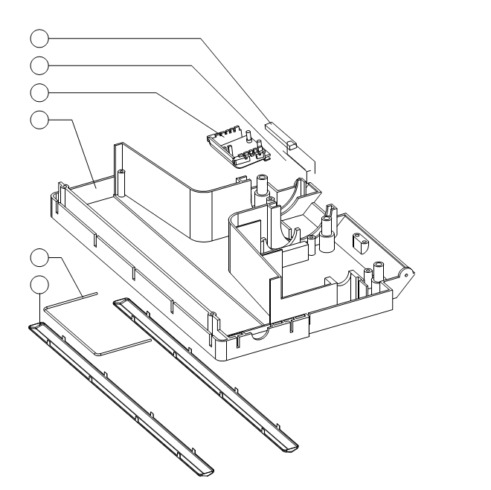
5
6
1
2
3
4

 | ITEM | SKU | DESCRIPTION | QTY
 | 1 | E82182 | Felt for Switch Housing | 1
 | 2 | E82181 | Felt for Brush Housing | 1
 | 3 | E82180 | DM1400/1800 switch housing w/o felt | 1
 | 4 | E82236 | Brush housing bottom 14", gray | 1
 | 5 | E82191 | DM1400/1800 brush protector | 1
 | 6 | E82188 | DM1400 brush protector | 2

Drawing Reference Q

Brush cover assembly DM1800

1

2

4
5
6

3

7
8
9

 | ITEM | SKU | DESCRIPTION | QTY
 | 1 | E82174 | DM1400/1800 bearing bushing short | 1
 | 2 | E82234 | DM1800 brush cover | 1
 | 3 | E82102 | Gasket 6x5 mm Neoprene Sealed ZK | 1
 | 4 | E82169 | DM1400/1800 LED cover | 1
 | 5 | E82168 | DM1400/1800 decal | 1
 | 6 | E82172 | DM1400/1800 latch break | 2
 | 7 | E82173 | DM1400/1800 bearing bushing long | 1
 | 8 | E82179 | DM1400/1800 front caster shaft fixing plate | 1
 | 9 | E82097 | DM1400/1800 screw | 1

.

Drawing Reference R

Brush housing assembly DM1800
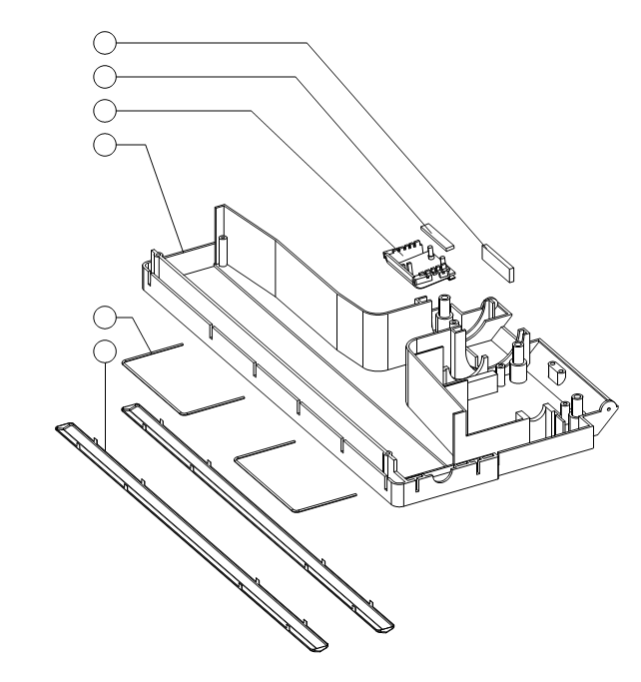
5
6
1
2

3
4

 | ITEM | SKU | DESCRIPTION | QTY
 | 1 | E82182 | Felt for Switch Housing | 1
 | 2 | E82181 | Felt for Brush Housing | 1
 | 3 | E82180 | DM1400/1800 switch housing w/o felt | 1
 | 4 | E82189 | DM1800 brush housing lower | 1
 | 5 | E82191 | DM1400/1800 brush protector | 2
 | 6 | E82188 | DM1400 brush protector | 2

S.02.0031.5

Upholstry tool with bristle 32 mm
Separate Parts are not available for this tool complete assembly E82238

NA

NA

Dust filter holder assembly

2 E82139 Filter Holder

1 E82140 Dust Filter

Motor housing assembly

1

2

3

4

5

6

 | ITEM | SKU | DESCRIPTION | QTY
 | 1 | E82141 | Door restrain | 1
 | 2 | E82099 | Screw 3x8 | 1
 | 3 | E82104 | Washer plain M4 steel | 1
 | 4 | E82151 | Motor Housing | 1
 | 5 | E82153 | Gasket Motor housing 2 | 1
 | 6 | E82143 | Foam motor | 1
 | 7 | E82152 | Gasket Motor housing 1 | 1

7

.

E82245 | Front Caster Adjustment Knob

Drawing Reference D

E85880 Brush Motor Assembly

1 E85889 Cogged Drive

TOP

BOTTOM

I

